**FOR IMMEDIATE RELEASE October 21, 2024**

**Hong Kong Rowing Schools Championships 2024 Conclude with Spectacular Victories**

The Hong Kong Rowing Schools Championships 2024, hosted by the Hong Kong, China Rowing Association in collaboration with the Hong Kong Schools Sports Federation, was successfully held last weekend at the Shing Mun River in Sha Tin, drawing over 150 participants from more than 50 schools across the region, including teams from as far away as Singapore. This year's event marked a record number of participating schools, creating a vibrant atmosphere both within and around the venue, solidifying its status as one of the most significant inter-school sporting events of the year.

The event showcased a series of competitions spanning various age groups, enabling students from beginner to advanced levels to participate and exhibit their skills. The remarkable hard work and dedication of these young rowers were clearly evident as they demonstrated their commitment and teamwork on the water. In addition to serving as a competitive platform, the championships significantly contributed to the advancement of school rowing across Hong Kong, playing a vital role in nurturing the next generation of athletes.

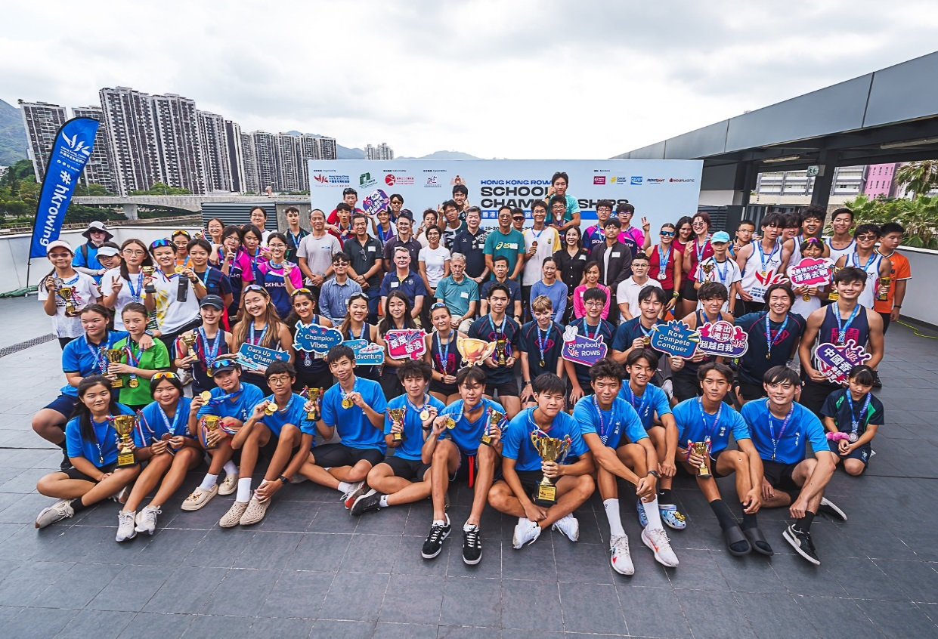

(Group Photos Captured with All Participants and Guests on 20 October 2024)

At the awards ceremony, Mr. Edmond HUNG Chor Ying, Chairman of The Schools Sports Federation of Hong Kong, China, delivered an inspiring address in which he commended the dedication and hard work of all participating schools. He highlighted that rowing serves not only to enhance students' physical fitness and foster teamwork but also plays a significant role in promoting personal mental development.

We are delighted to extend a warm welcome to our esteemed guests and supporters who joined students, coaches, and parents in celebrating the remarkable achievements of our young athletes.

The event was graced by the presence of distinguished guests, including **Mr. Edmond HUNG Chor Ying**, Chairman of The Schools Sports Federation of Hong Kong, China, **Mr. Robbie MCROBBIE**, Executive Manager, Charities (Sports), Hong Kong Jockey Club, **Ms. LAU Yuen Shan, Ada**, Leisure Manager (Sports Dev), Leisure & Cultural Services Department, **Mr. LAM Ping Kwan, Watson**, Liaison Officer In Charge of the Sha Tin District Office, **Mr. WONG Kin-ho**, Chairman of the Hong Kong Education Workers Union, **Ms. LEE Ka Man, OLY**, Director of the Hong Kong, China Rowing Association and **Mr. Mike TANNER, BBS, MH**, President of Hong Kong, China Rowing Association & Director of ROWSport.

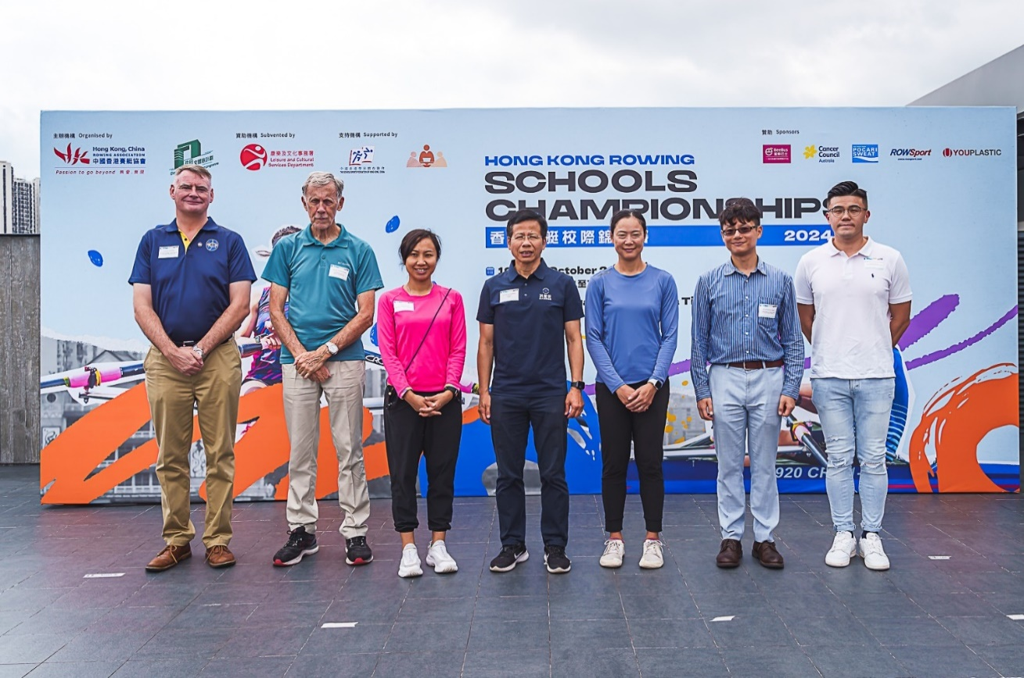

*From left: Mr. Robbie MCROBBIE, Executive Manager, Charities (Sports), Hong Kong Jockey Club; Mr. Mike TANNER, BBS, MH, President of Hong Kong, China Rowing Association & Director of ROWSport; Ms. LAU Yuen Shan, Ada, Leisure Manager (Sports Dev), Leisure & Cultural Services Department; Mr. Edmond HUNG Chor Ying, Chairman of The Schools Sports Federation of Hong Kong, China; Ms. LEE Ka Man, OLY, Director of the Hong Kong, China Rowing Association; Mr. LAM Ping Kwan, Watson, Liaison Officer In Charge of the Sha Tin District Office; Mr. WONG Kin-ho, Chairman of the Hong Kong Education Workers Union*

The Hong Kong Rowing Schools Championships 2024 highlighted the dynamic expansion of rowing within the academic community, reflecting its surging popularity among schools in the region. In response to this growing interest, the organizing committee announced its commitment to further elevate the scale and quality of future events, aimed at fostering greater participation from schools and creating enhanced opportunities for students to demonstrate their athletic talents.

We are confident that future Hong Kong Rowing Schools Championships will engage a broader array of schools, revitalizing the growth of rowing in Hong Kong and solidifying the sport as a vital component of students' development.

Please refer to the link for the race results:

[**http://www.rowing.org.hk/hk/competition/hong-kong-rowing-schools-championships/**](http://www.rowing.org.hk/hk/competition/hong-kong-rowing-schools-championships/)

For media inquiries, please contact **Ms. Ang LAU**, Head of Events and Marketing.

Contact information: [ang.l@rowing.org.hk](mailto:ang.l@rowing.org.hk) / +852-3841-7219

For more information, please visit <http://www.rowing.org.hk/>